**Comprehensive Well Evaluation: A Deep Dive into Well Analysis Case Study**

**PROBLEM STATEMENT:** This case study focuses on using the ShaleWellCube database, provided by Rystad Energy, which contains data on over 1.5 million wells in the US, Canada, and Argentina. The main goal is to analyze historical production records and various well attributes in detail. Additionally, the study aims to enhance insights by incorporating projected production figures, cost assessments, pricing evaluations, financial computations, and coverage of flaring and venting activities. The key objectives include describing well characteristics, predicting US production trends, comparing well, operator, and basin performance, and extracting valuable insights from the ShaleWellCube data.

**WHAT IS EXPECTED?**

This extensive case study examines the L48 oil supply landscape with a data-driven approach and projections. Key objectives include assessing oil, gas, and NGL supply at the regional level up to 2024, analyzing L48 Activity Metrics to track trends, benchmarking operational performance across public and private operators, conducting an economic assessment of well performance, and centralizing technical data on shale wells. The study's data engineering perspective involves integrating, cleaning, transforming, and enriching diverse datasets for comprehensive analysis. Specific questions addressed in the study relate to historical and forecasted production, top operators by well count, flaring data, monthly production in shale plays, average well length, and the comparison of Ethane and dry gas production for specific operators.

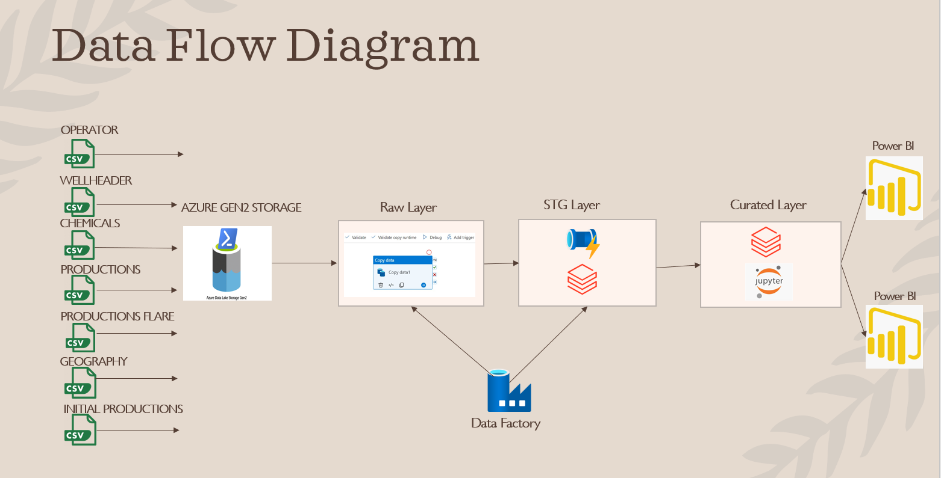

**MOUNTING THE DATA IN DATABRICKS**

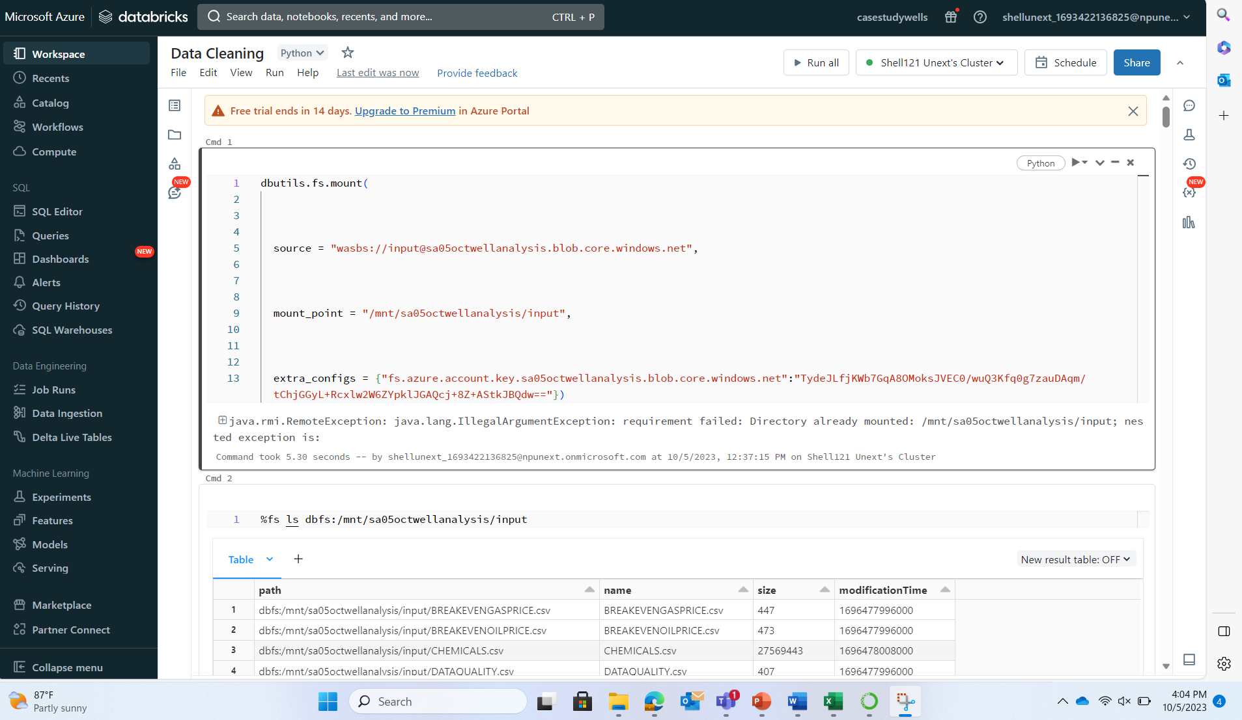

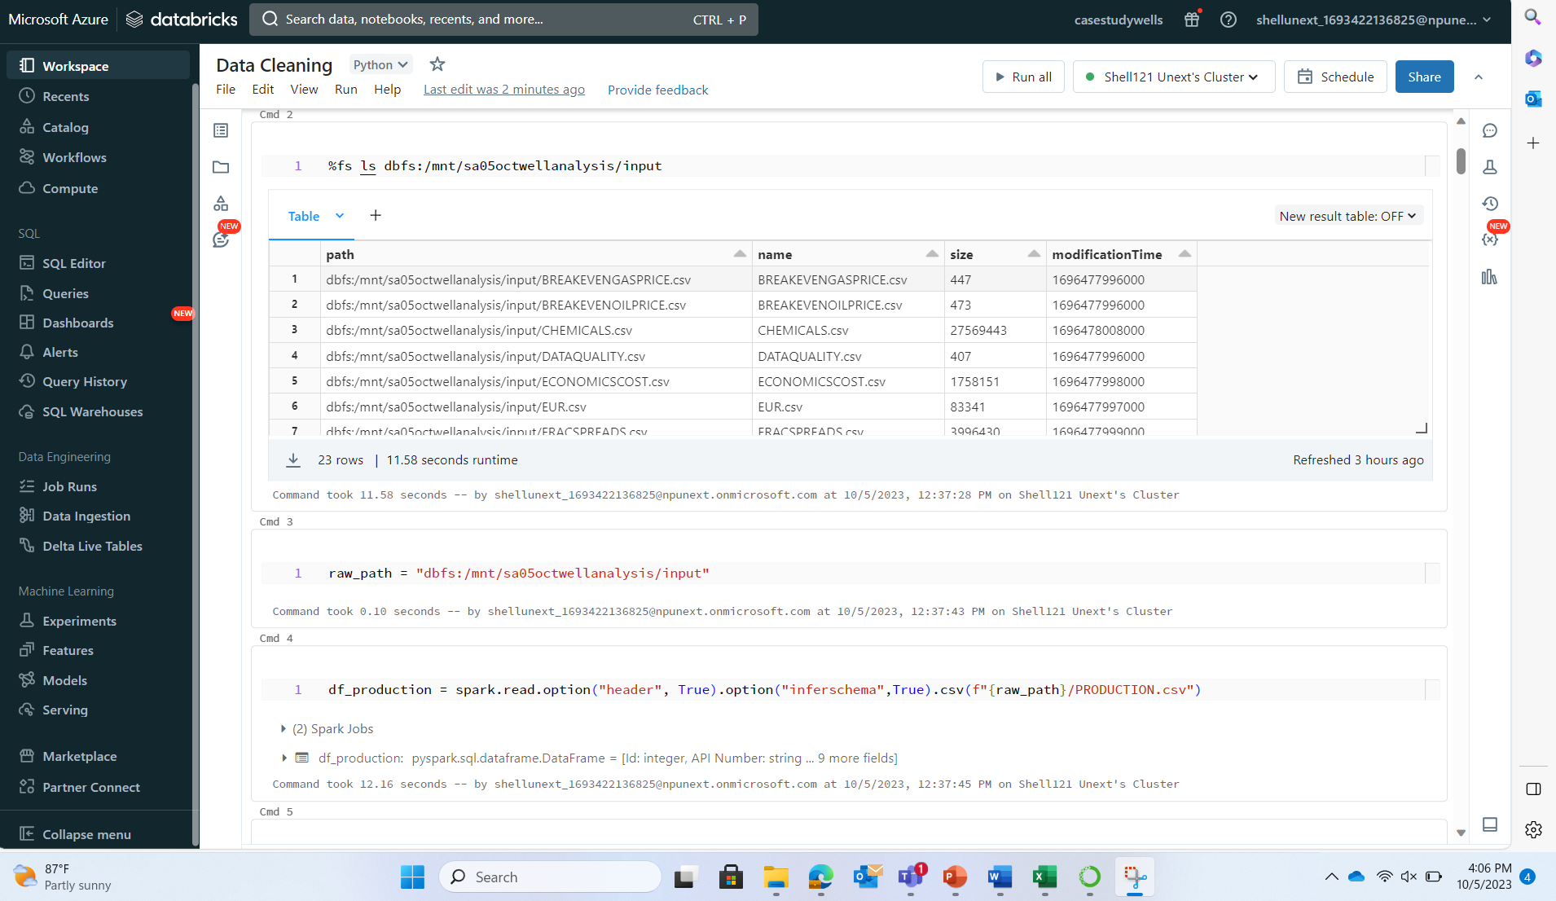

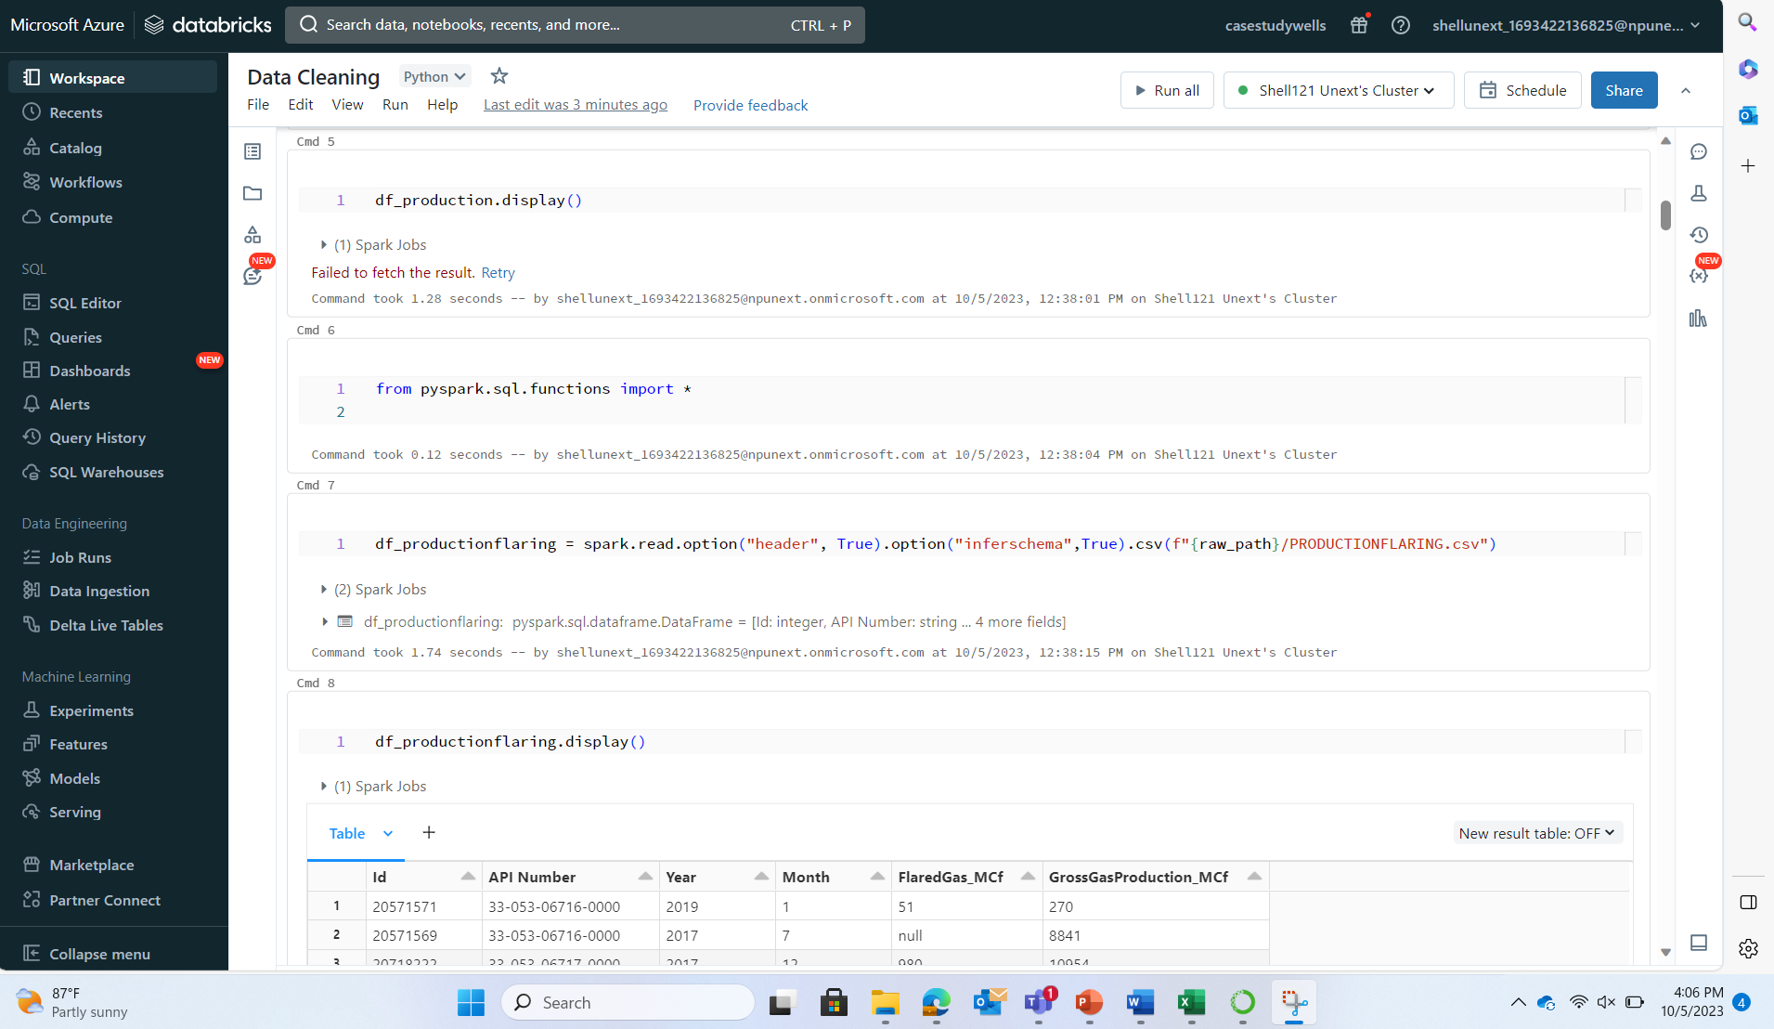

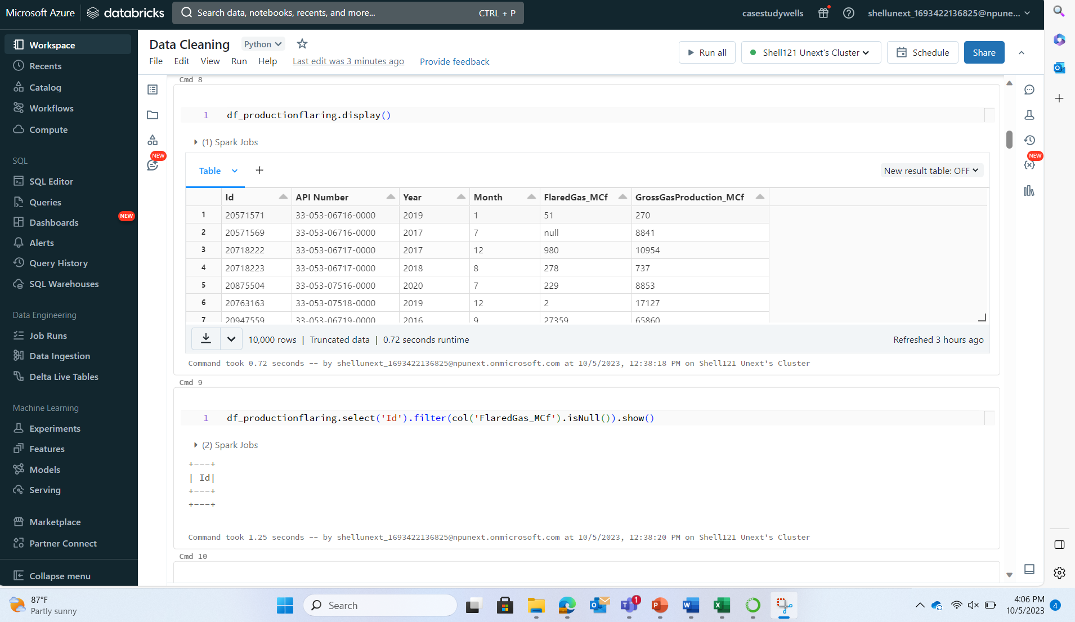

**CLEANING THE DATA IN DATABRICKS**

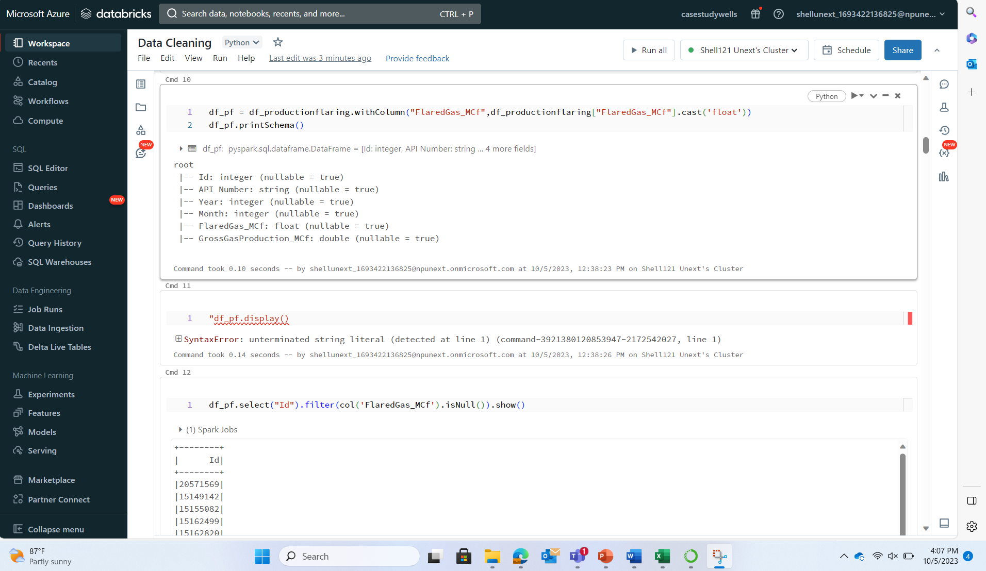

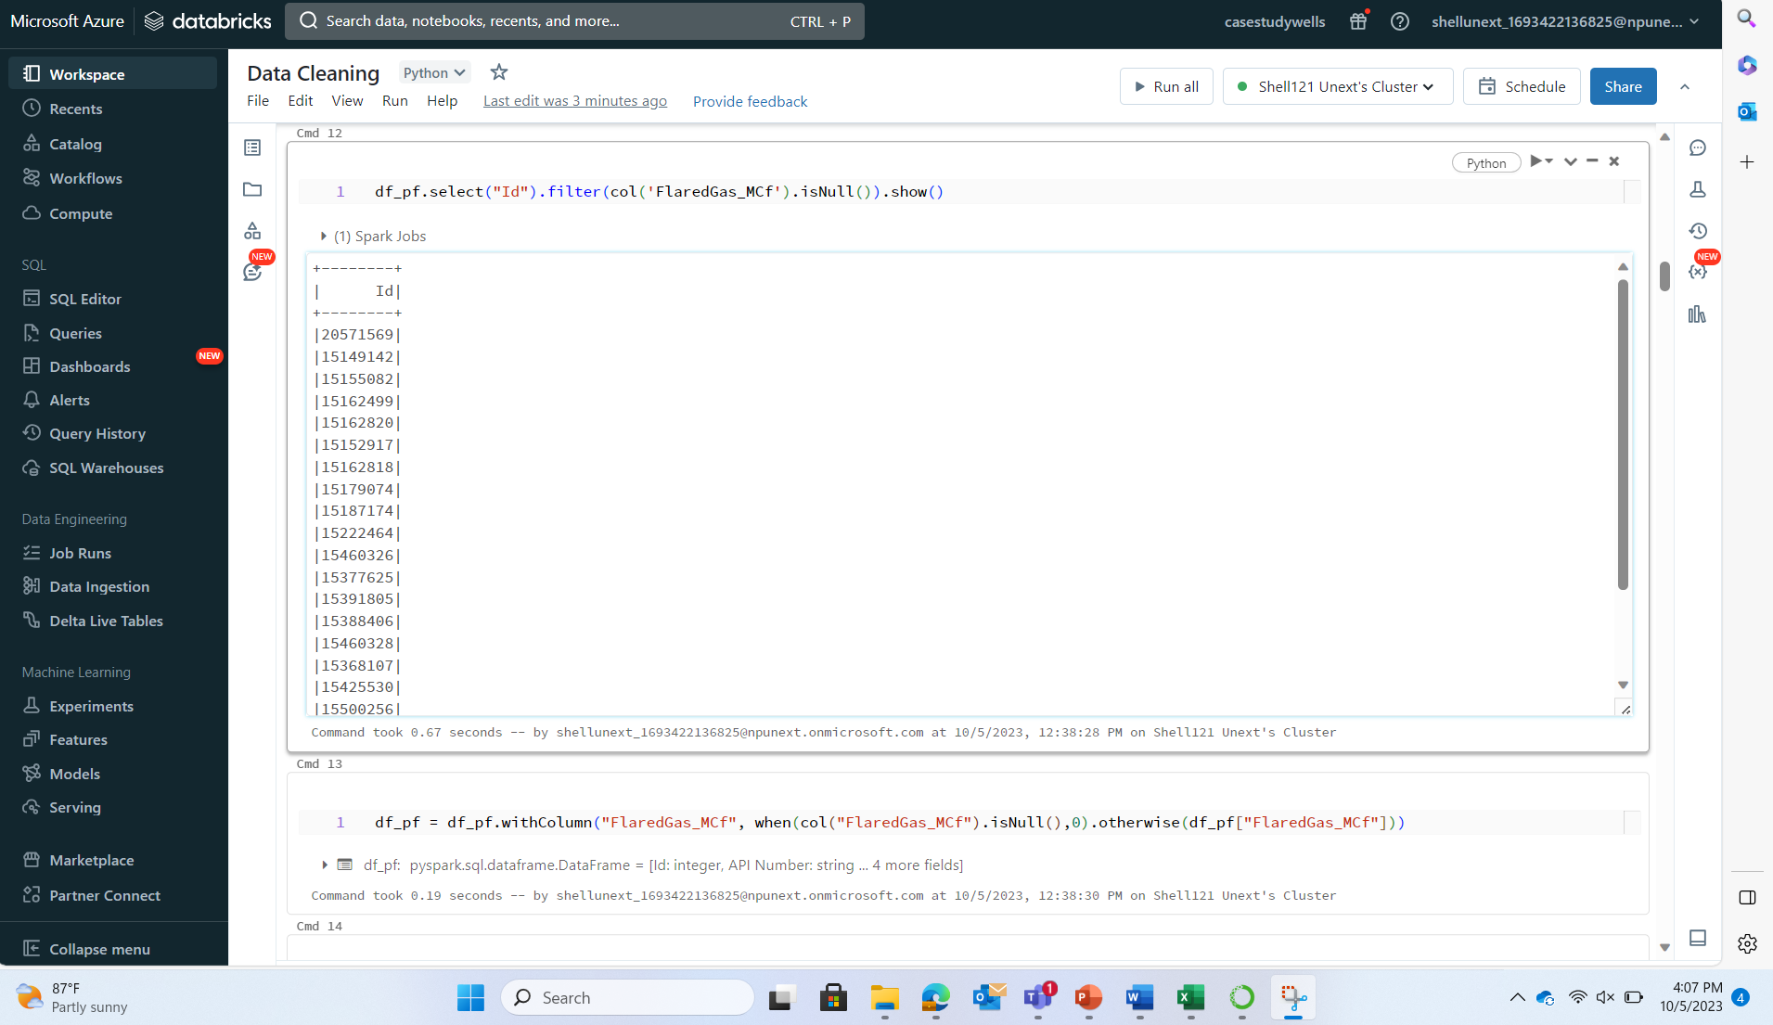

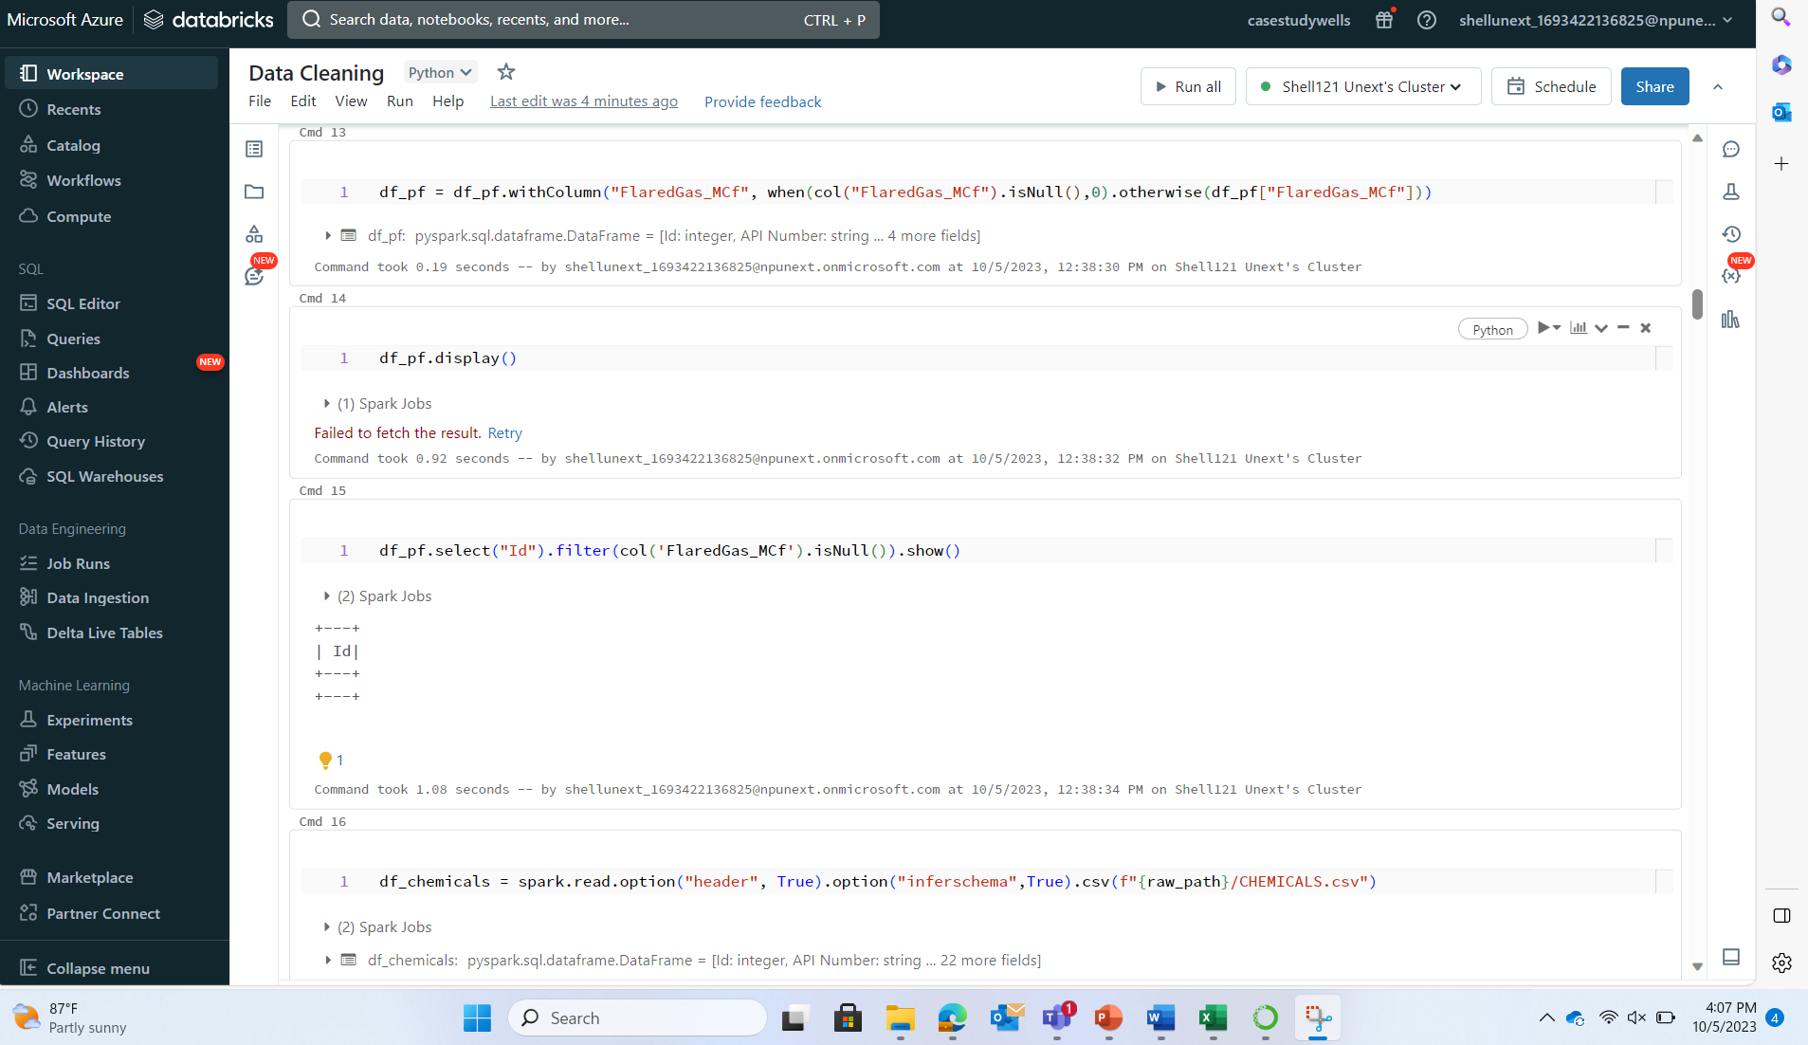

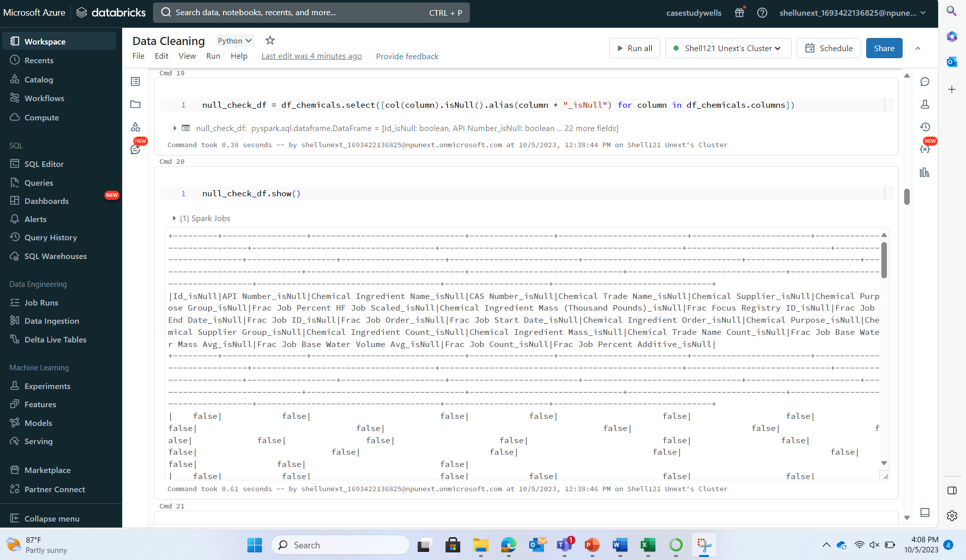

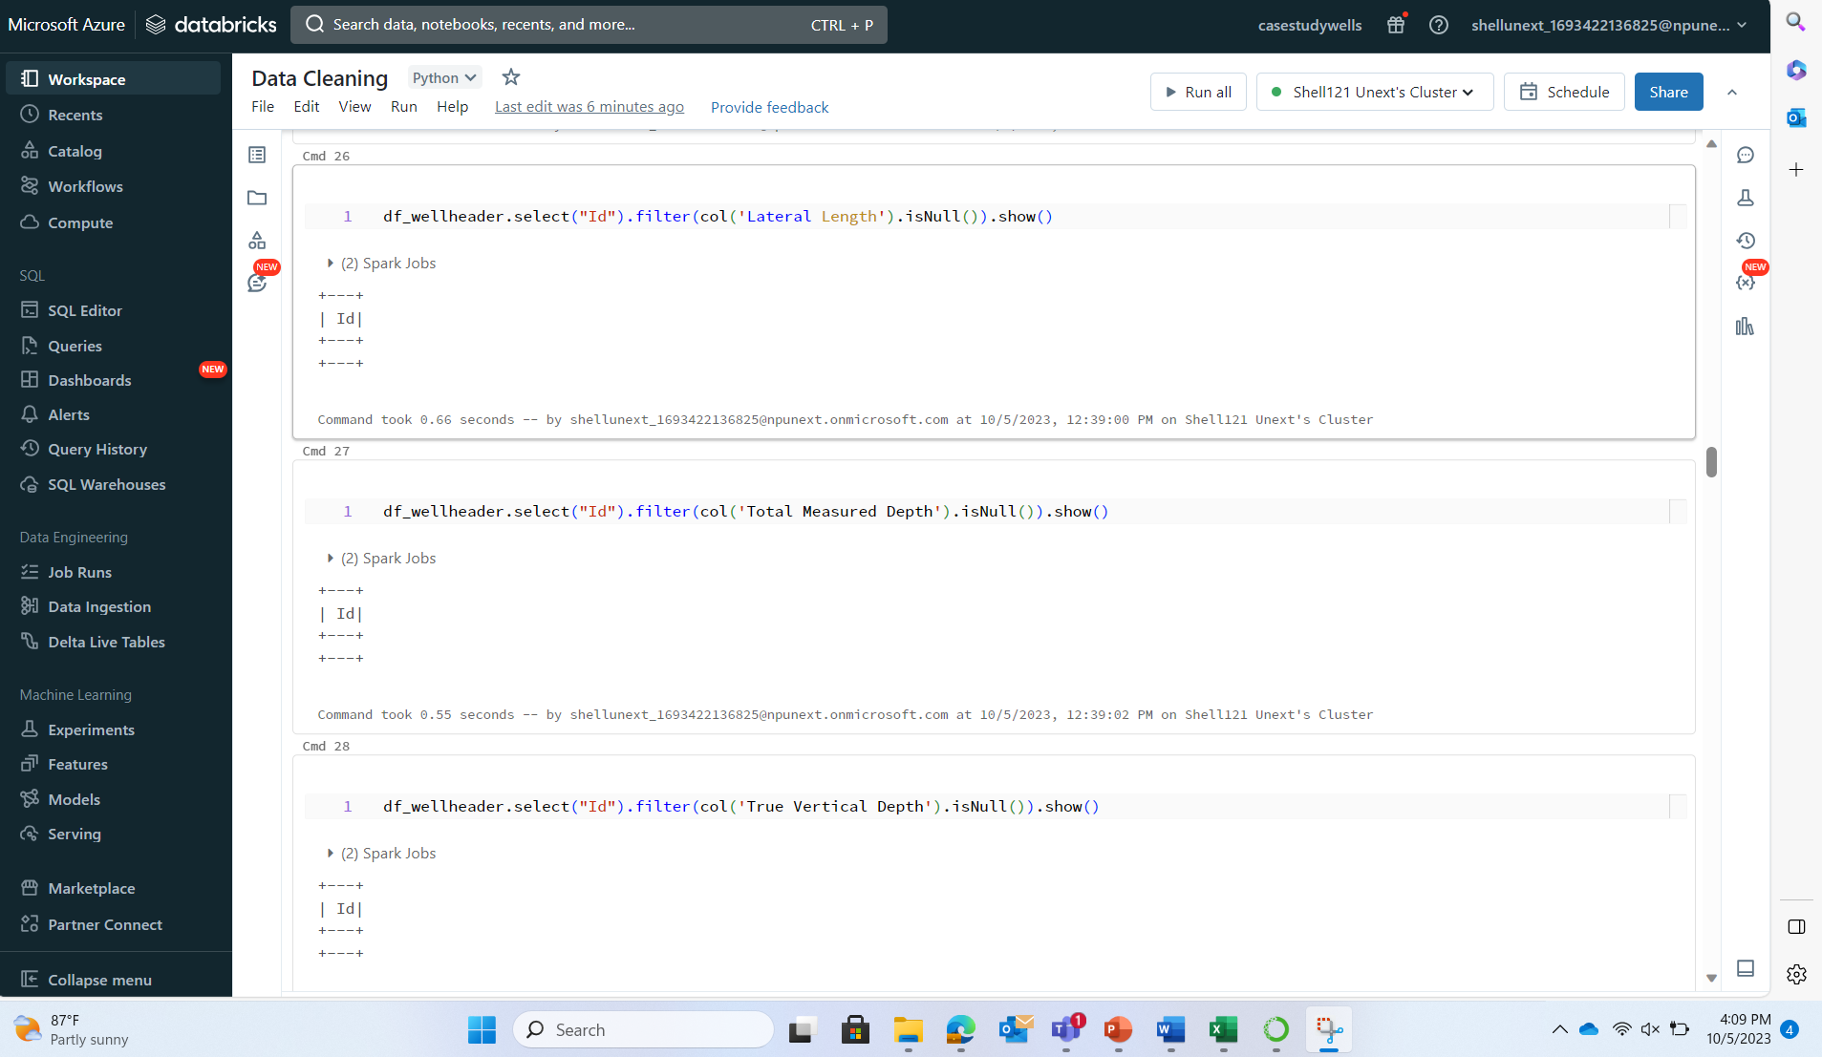

**DATA TRANSFORMATION IN DATABRICKS**

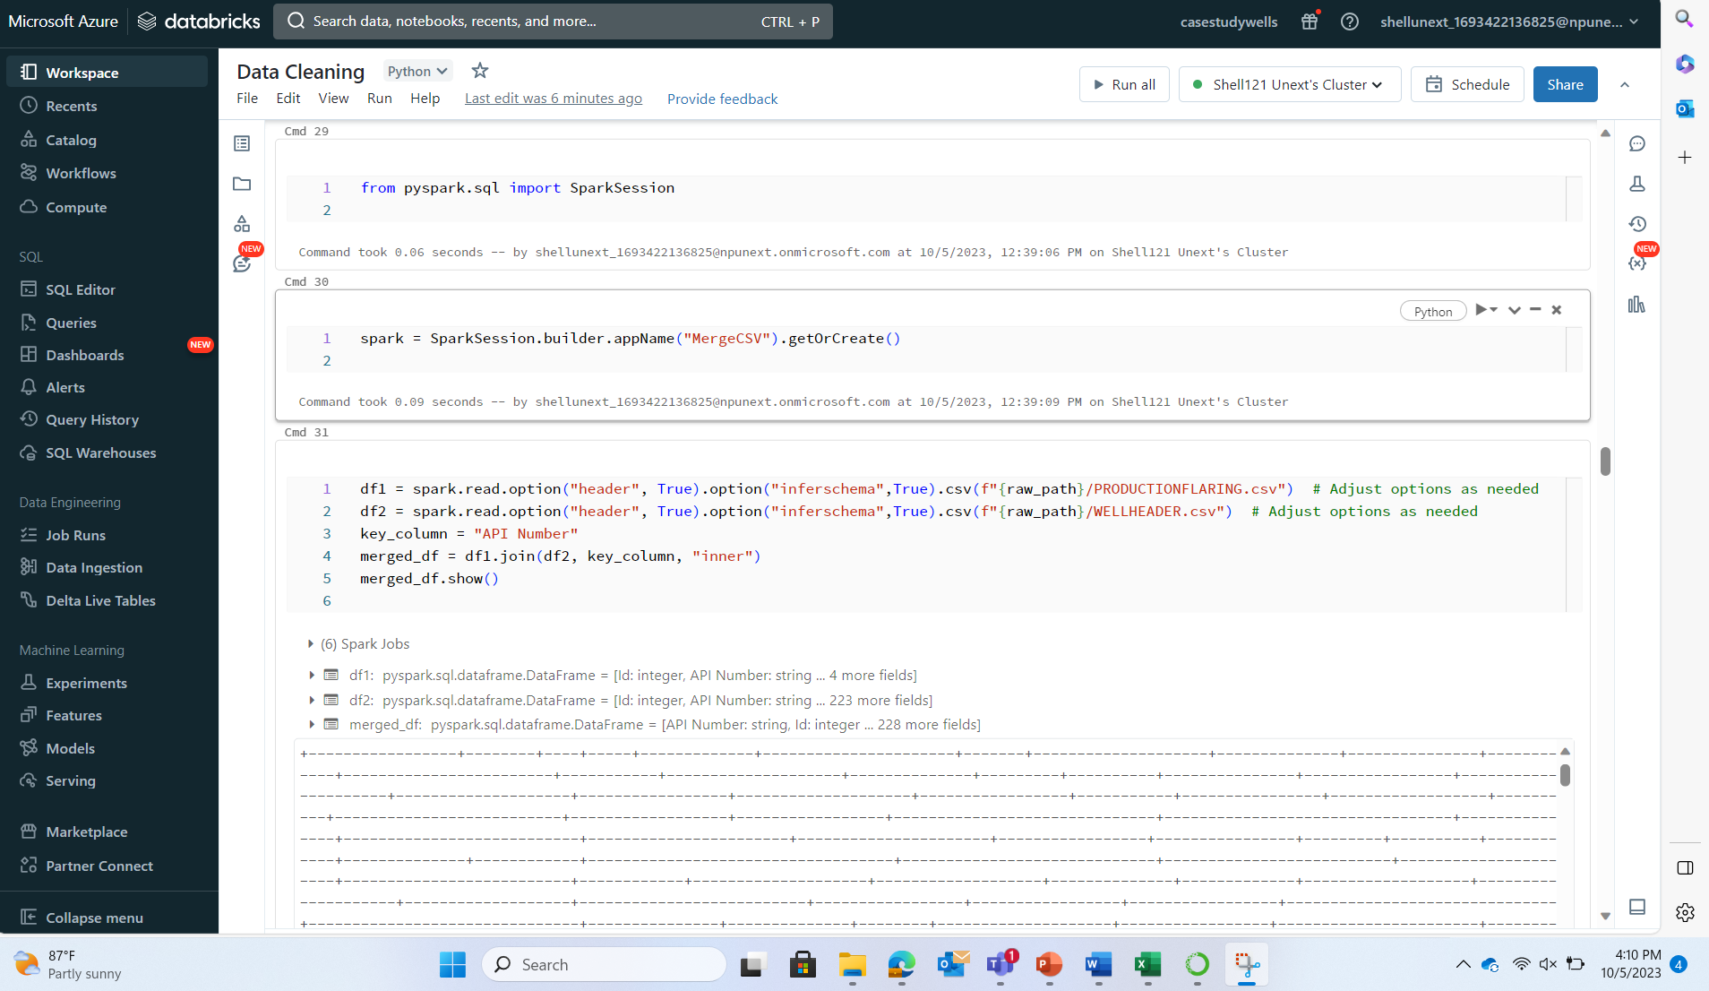

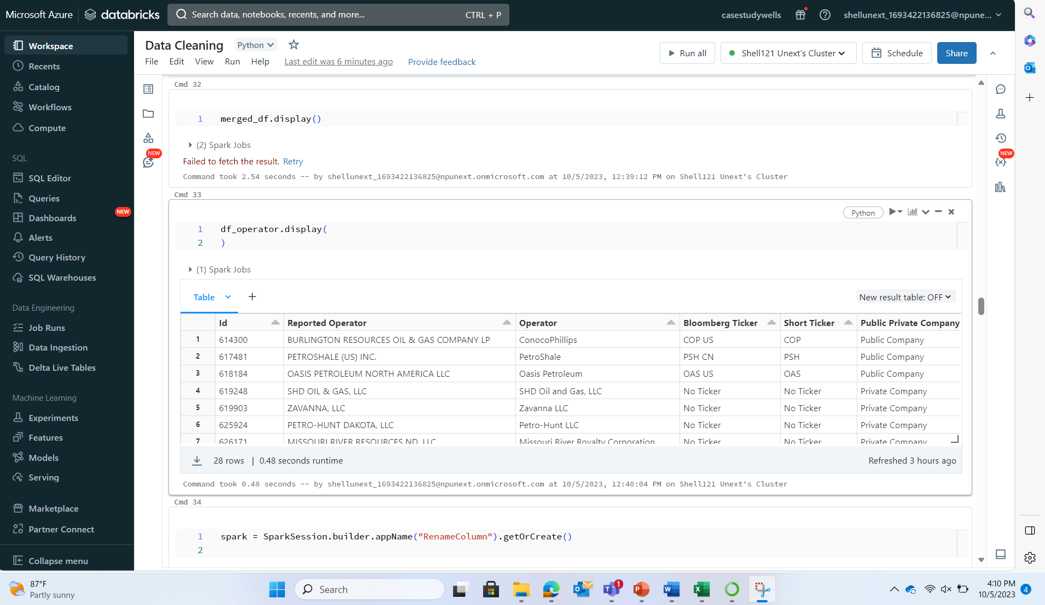

**QUESTION 01: Historical and Forecast Production?**

Historic- Initial Production table and Production

Forecast Production- Production Table

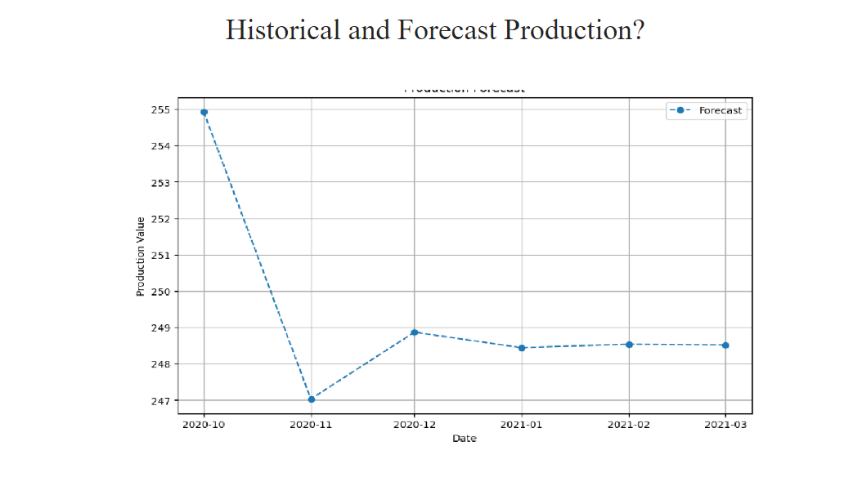

**QUESTION 02: Operators With Highest Well Count?**

**DATABRICKS:**

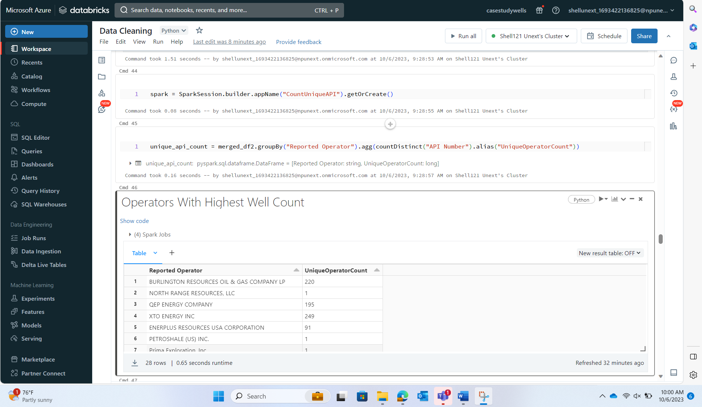

**POWERBI:**

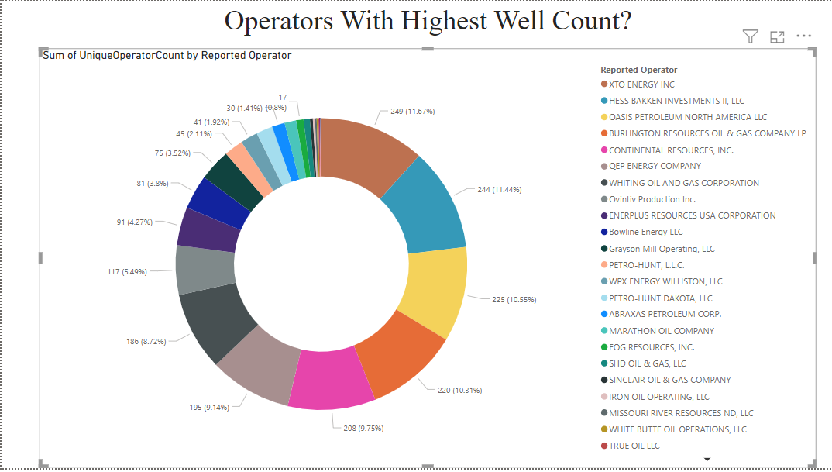

**QUESTION 03: Who are Flaring More?**

**DATABRICKS:**

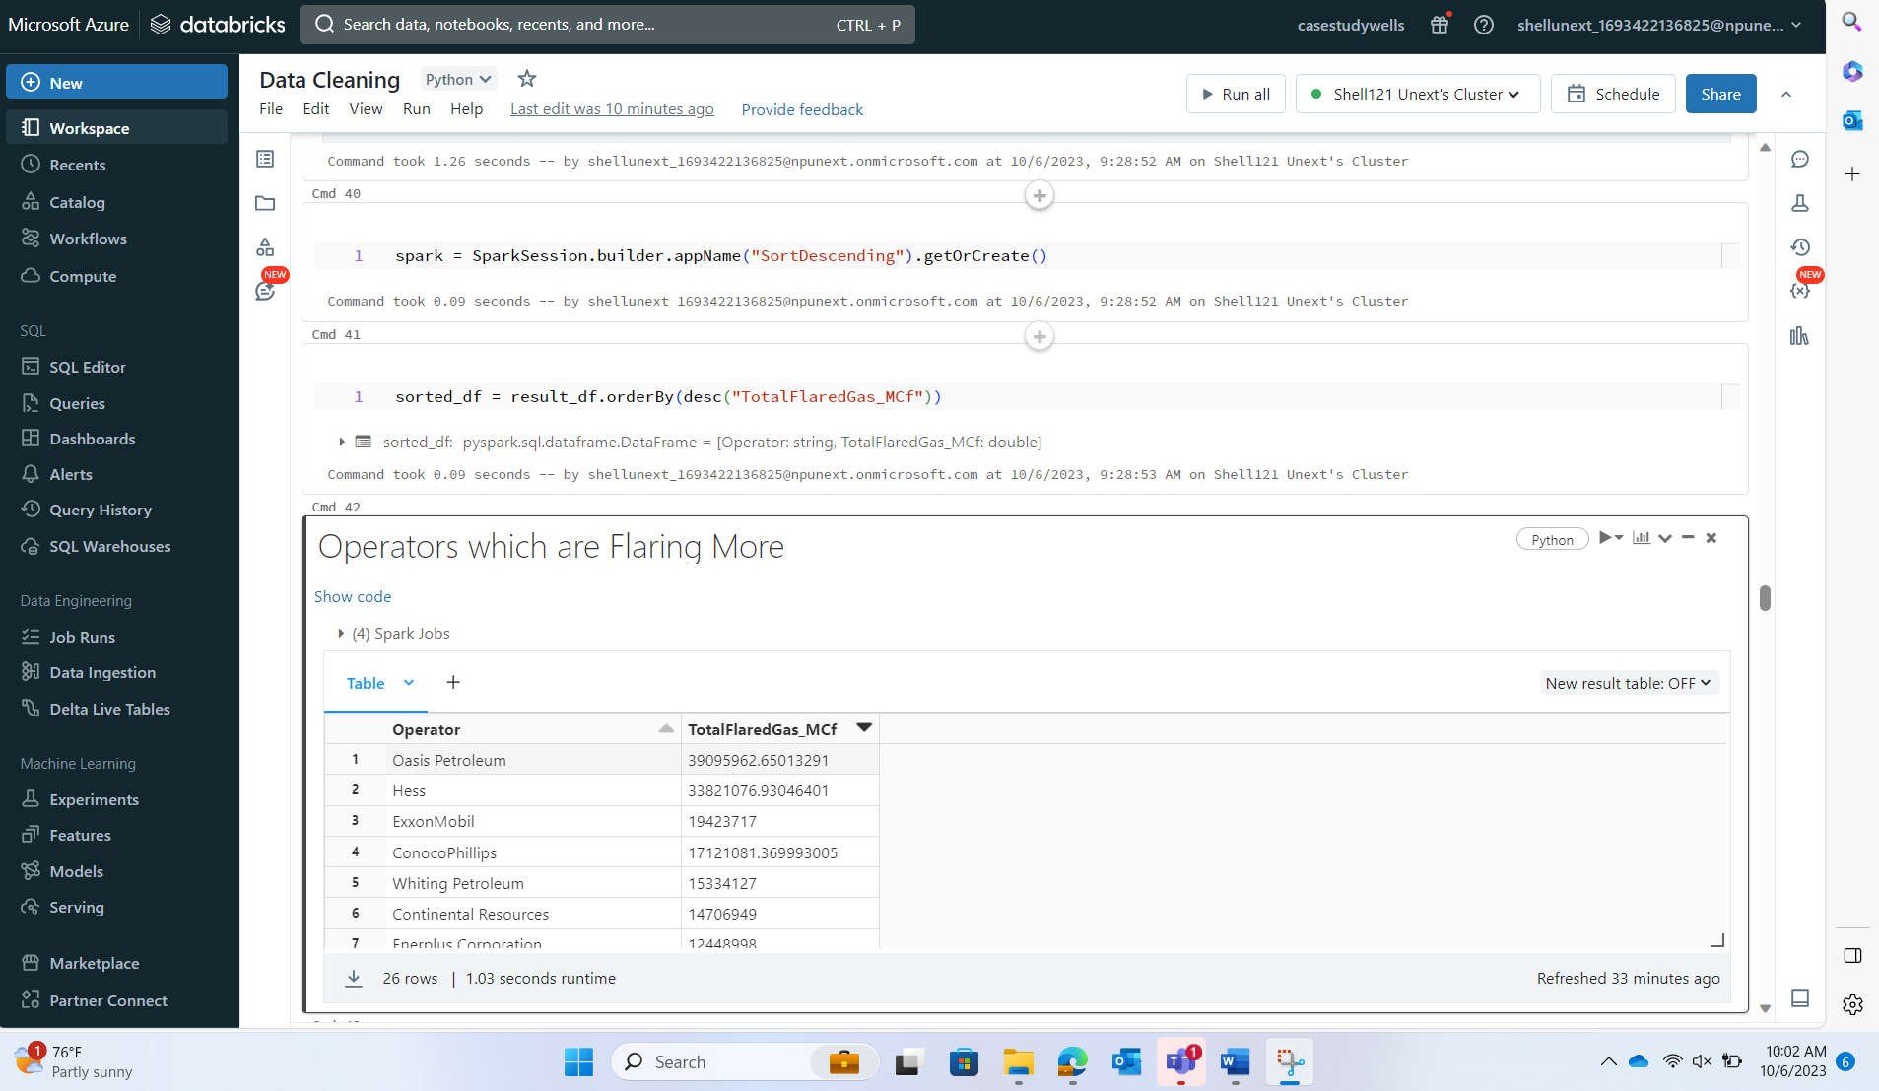

**POWERBI:**

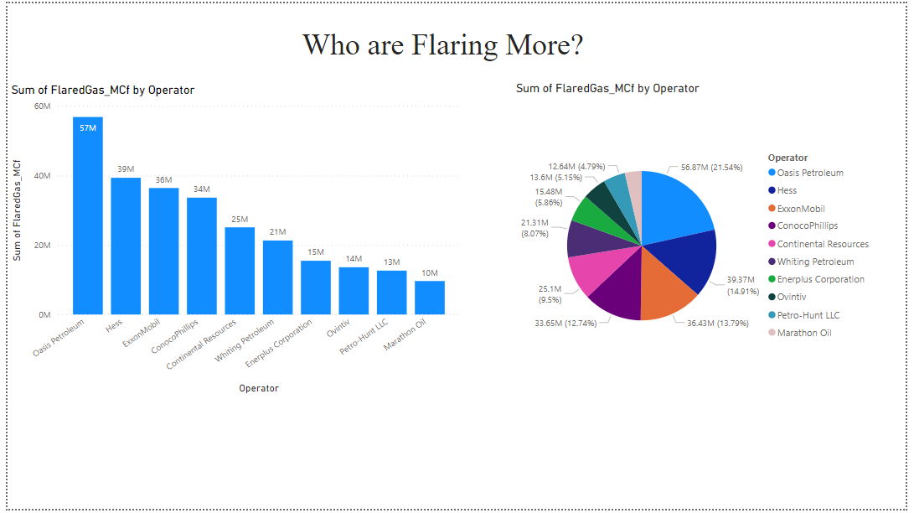

**QUESTION 04: Which shale play has the highest monthly production of oil and gas combined?**

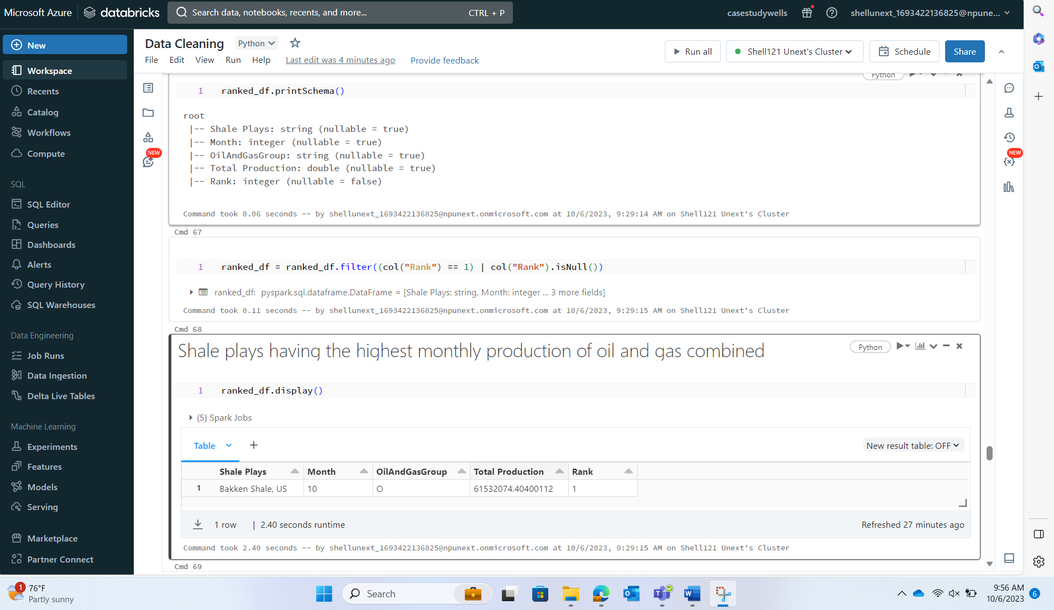

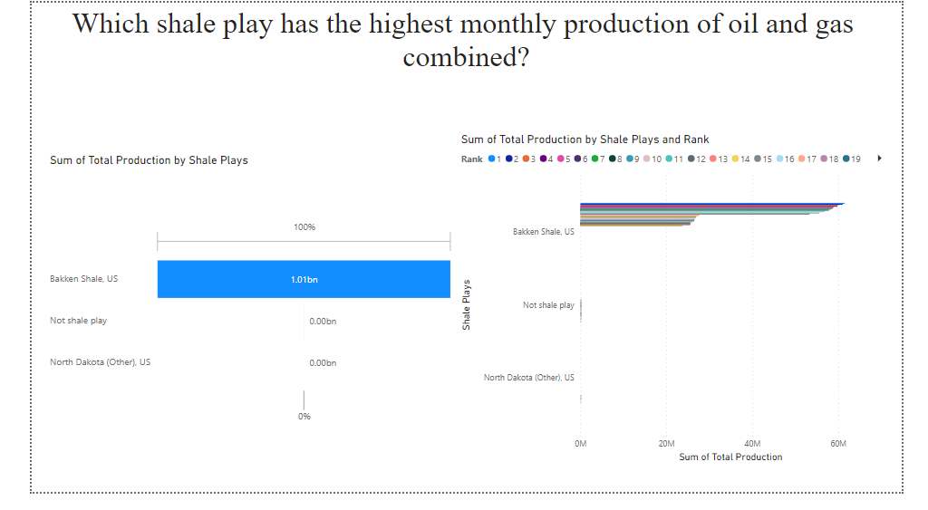

**QUESTION 05: What is the average well length across all wells in the dataset?.**

**DATABRICKS:**

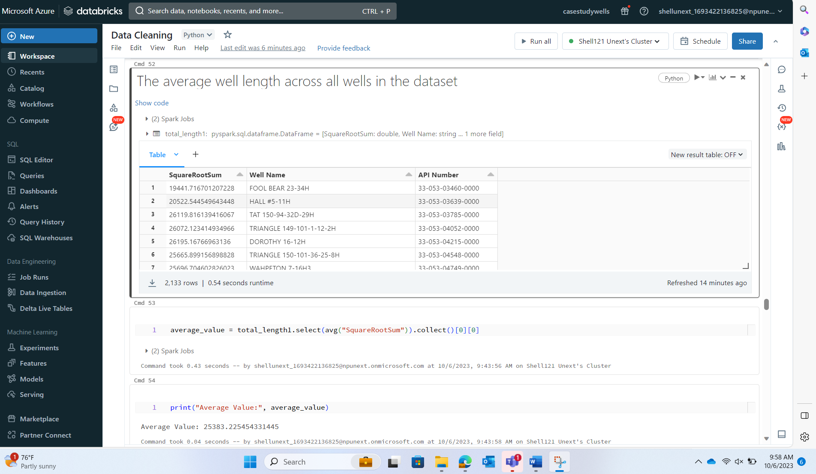

**POWERBI:**

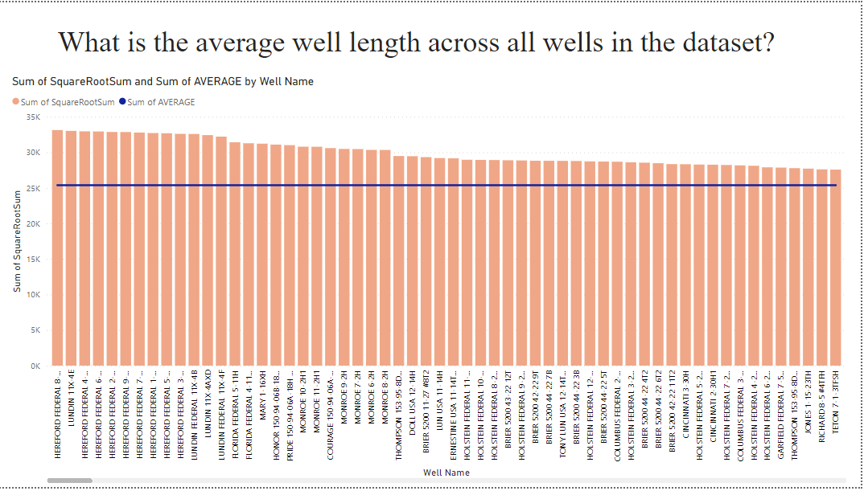

**QUESTION 06: How does the monthly production of Ethane compare to that of dry gas for a specific operator?**

**DATABRICKS:**

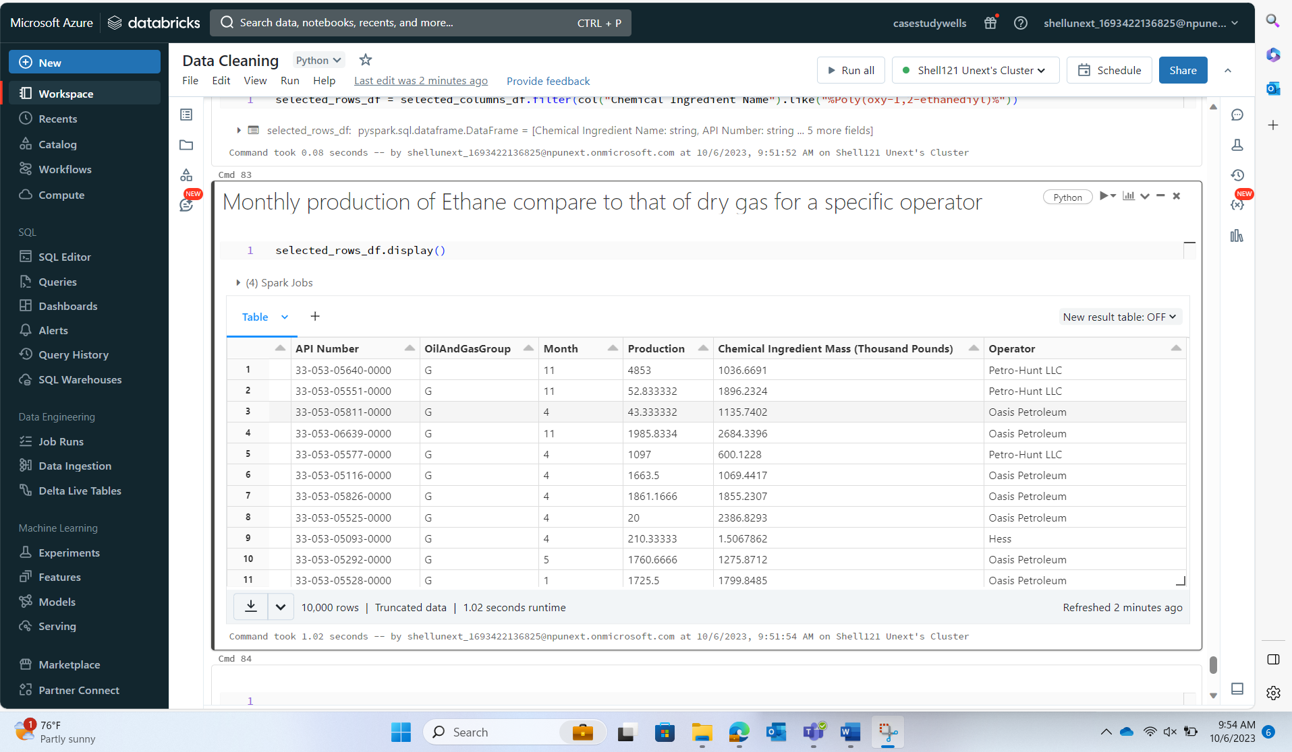

**POWERBI:**

